Go to Membership tab  
Log in to ENgage (using your ENA ID number)  
Select Find a Club  
Enter Chelmsford in the name section and club in the type section  
Select Chelmsford (Senior Club), Org Ref ID 678  
  
1. Select Buy membership

NB. If you are an existing CNC member and you are buying your 22/23 membership before 31Aug22, then you will show as an active member and it looks like you are still buying membership for 2021-22. However, still select “buy membership” and this will take you to a screen that allows you to renew current membership with a start date of 31Aug22 i.e. the 2022/23 season.

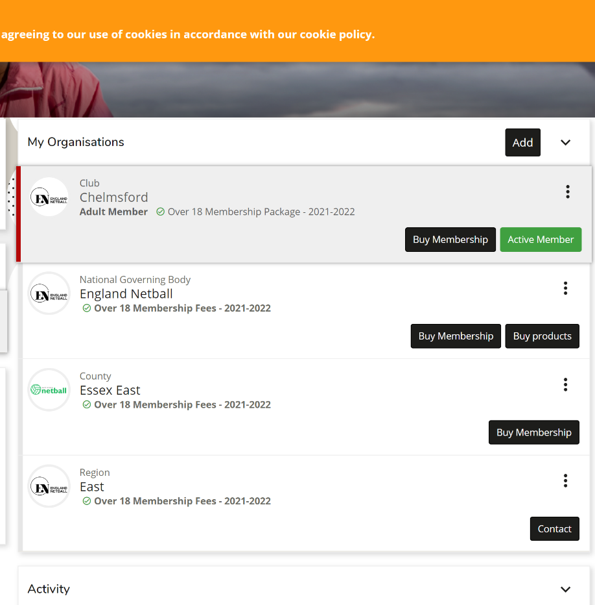

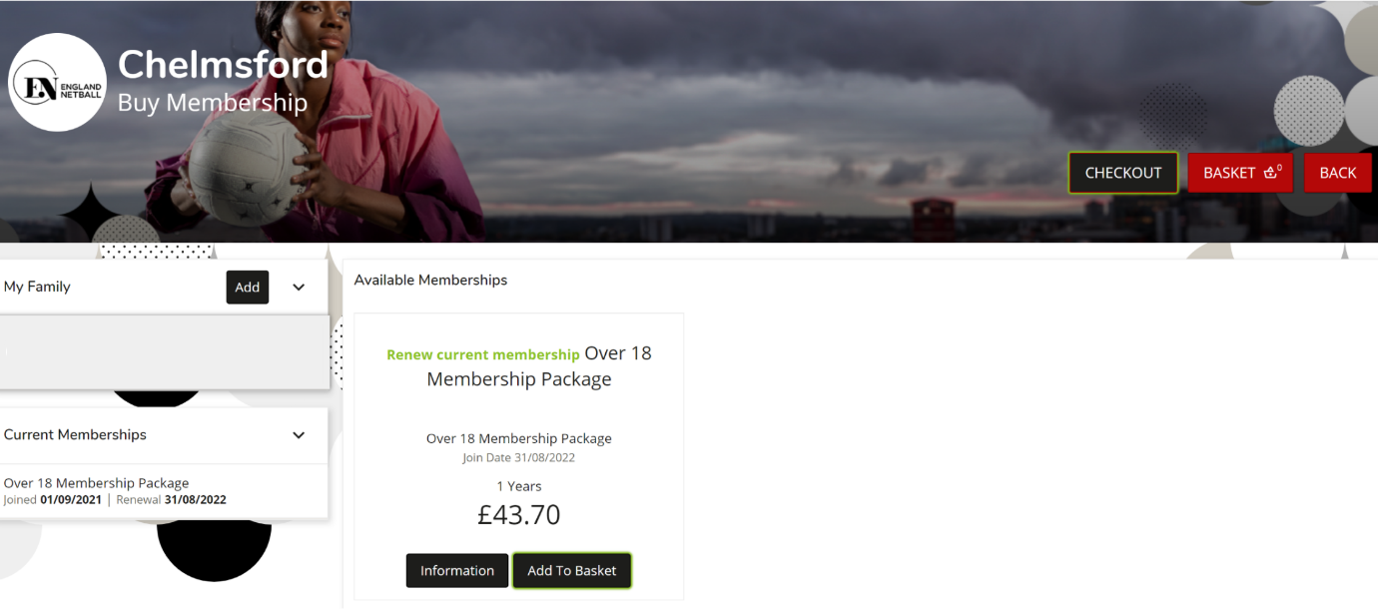

2. Select the wanted membership (ensure you select 2022-23 and either Adult or Junior U18)  
  
3. Select Checkout   
  
4.  Select the circle next to the wanted payment method  
  
5    Select Pay now  
  
6.   Enter your payment details  
  
If you do not have an existing ENA ID number, then you will need to create an account when you try to log in to ENgage.  
  
Adult membership is £43.70 and Under 18 membership is £20.10